Lab Manual 1

NETWORK ESSENTIALS LAB Manual
User mode : Basic Ping , Basic Trace , Basic show commands .
Privilege Mode : If you want to do complete monitoring , Complete show commands then PM .
100 per commands only show .
Global Configuration mode : Any changes then Global config mode .

Basic configuration – Hostname, Clock, no ip domain lookup. Setting up History size
R1(config)#hostname R1
R1#clock set 10:10:10 march 10 2020
R1(config)#no ip domain-lookup
R1#terminal history size ?
<0-256> Size of history buffer

Configure login banner
R1(config)#banner motd $ ALERT - HEADOFFICE ROUTE$
Configure Password(Enable,Console,Telnet)

R1(config)#enable password cisco

Encrypt password
R1(config)#service password-encryption
R1(config)#enable secret cisco123

Save all configurations .
R1#copy running-config startup-config
Destination filename [startup-config]?
Building configuration...
[OK]
Remove all configurations
Router#erase startup-config

Restart Router and switch
Router#reload

R1(config)#line con 0
R1(config-line)#password cisco
R1(config-line)#login
R1(config-line)#exi

TELNET – Pre requisites

1.Connectivity
2.Enable password

Then configure telnet with below commands

R1(config)#line vty 0
R1(config-line)#password cisco
R1(config-line)#login
R1(config-line)#exi

R1(config)#username AAA password AAA
R1(config)#line vty 0 4
R1(config-line)#login local
R1(config-line)#exi

Password recovery – for routers

Physical OFF and ON
CTR+SHIFT+PAUSE/BREAK (Pause/Break or equivalent command depends upon diff laptops)
Self decompressing the image : #################################

monitor: command "boot" aborted due to user interruptp
rommon 1 > confreg 2142
rommon 2 > reset
Continue with configuration dialog? [yes/no]:no
Router>enab
Router#conf t
Router(config)#no enable password
Router(config)#no enable secret
Router#show version
Configuration register is 0x2142
Router(config)#config-register 2102
Router#reload
This time it will not ask for the password.

How to assign IP address to the interface of the Router
R1(config)#interface fastEthernet 0/0
R1(config-if)#ip address 10.0.0.1 255.0.0.0
R1(config-if)#no shutdown
R1(config-if)#exi

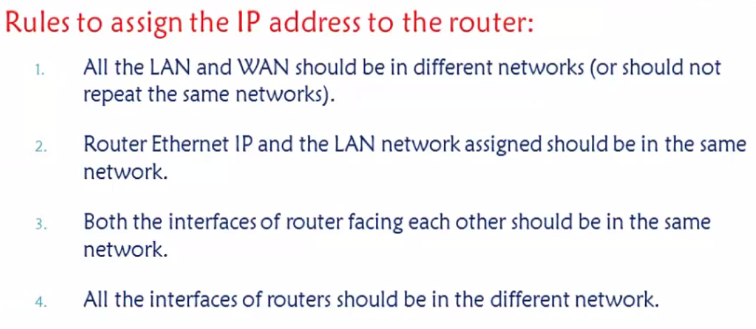

Static routing

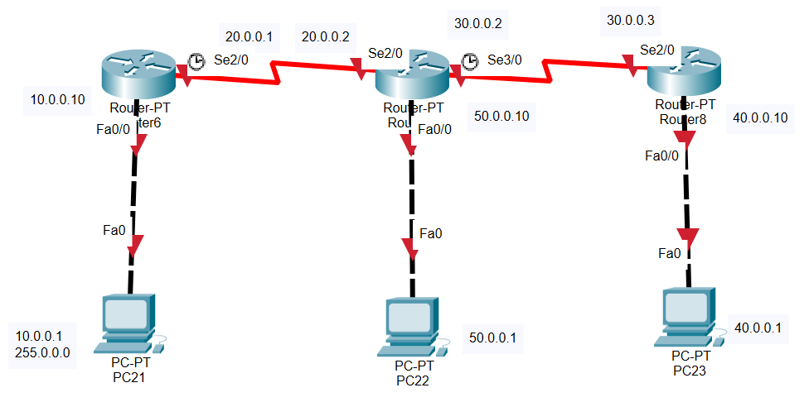
Default commands for Topology .

R1 , R2 , R3 -

R1
Conf ter
interface fastEthernet 0/0
no sh
ip address 10.0.0.10 255.0.0.0
exi
hostname R1
interface serial 2/0
ip address 20.0.0.1 255.0.0.0
no sh
exi

R2

Conf ter
hostname R2
interface serial 2/0
no sh
ip address 20.0.0.2 255.0.0.0
no sh
exi
interface serial 3/0
ip address 30.0.0.2 255.0.0.0
no sh
exi
interface fastEthernet 0/0
ip address 50.0.0.10 255.0.0.0
no sh
exi

R3

Conf ter
hostname R3
interface serial 2/0
ip address 30.0.0.3 255.0.0.0
no sh
exi
interface fastEthernet 0/0
no sh
ip address 40.0.0.10 255.0.0.0
no sh
exi
do sh his

R1
Ip route 30.0.0.0 255.0.0.0 20.0.0.2
Ip route 40.0.0.0 255.0.0.0 20.0.0.2
Ip route 50.0.0.0 255.0.0.0 20.0.0.2

R2
Ip route 10.0.0.0 255.0.0.0 20.0.0.1
Ip route 40.0.0.0 255.0.0.0 30.0.0.3

R3
Ip route 10.0.0.0 255.0.0.0 30.0.0.2
Ip route 20.0.0.0 255.0.0.0 30.0.0.2
Ip route 50.0.0.0 255.0.0.0 30.0.0.2

DEFAULT ROUTING

R1
Ip route 0.0.0.0 0.0.0.0 20.0.0.2

R2
Ip route 10.0.0.0 255.0.0.0 20.0.0.1
Ip route 40.0.0.0 255.0.0.0 30.0.0.3

R3
Ip route 0.0.0.0 0.0.0.0 30.0.0.2

SSH
SSH, also known as Secure Shell or Secure Socket Shell, is a network protocol that gives users, particularly system administrators, a secure way to access a computer over an unsecured network.
The default port for SSH client connections is 22 , Telnet 23
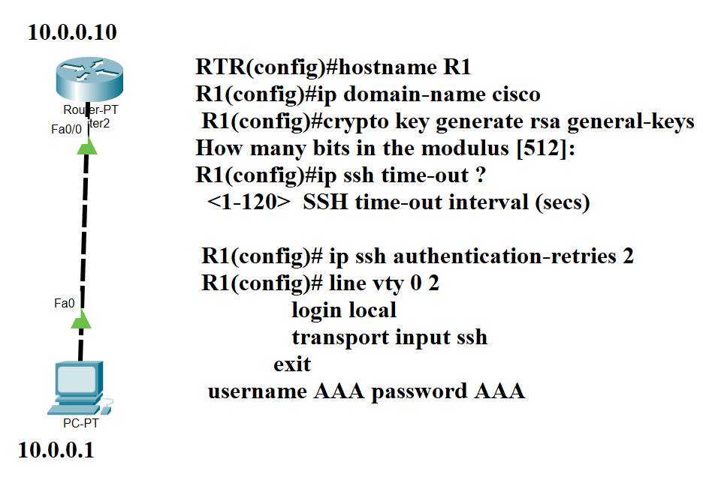
SSH –l AAA 10.0.0.10

RIP V1 and V2
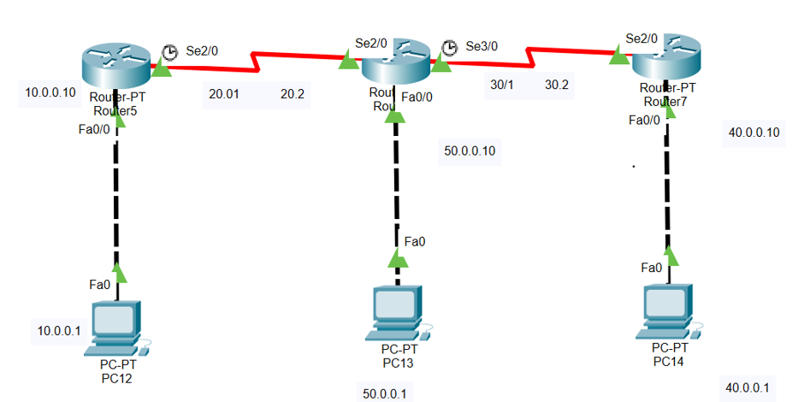
Default commands for Topology .

R1 , R2 , R3 -

R1
Conf ter
interface fastEthernet 0/0
no sh
ip address 10.0.0.10 255.0.0.0
exi
hostname R1
interface serial 2/0
ip address 20.0.0.1 255.0.0.0
no sh
exi

R2

Conf ter
hostname R2
interface serial 2/0
no sh
ip address 20.0.0.2 255.0.0.0
no sh
exi
interface serial 3/0
ip address 30.0.0.2 255.0.0.0
no sh
exi
interface fastEthernet 0/0
ip address 50.0.0.10 255.0.0.0
no sh
exi

R3

Conf ter
hostname R3
interface serial 2/0
ip address 30.0.0.3 255.0.0.0
no sh
exi
interface fastEthernet 0/0
no sh
ip address 40.0.0.10 255.0.0.0
no sh
exi

R1
router rip
version 2
network 10.0.0.0
network 20.0.0.0
no auto-summary
exit

R2
router rip
version 2
network 20.0.0.0
network 30.0.0.0
network 50.0.0.0
no auto-summary
exit

R13
router rip
version 2
network 30.0.0.0
network 40.0.0.0
no auto-summary
exit

EIGRP

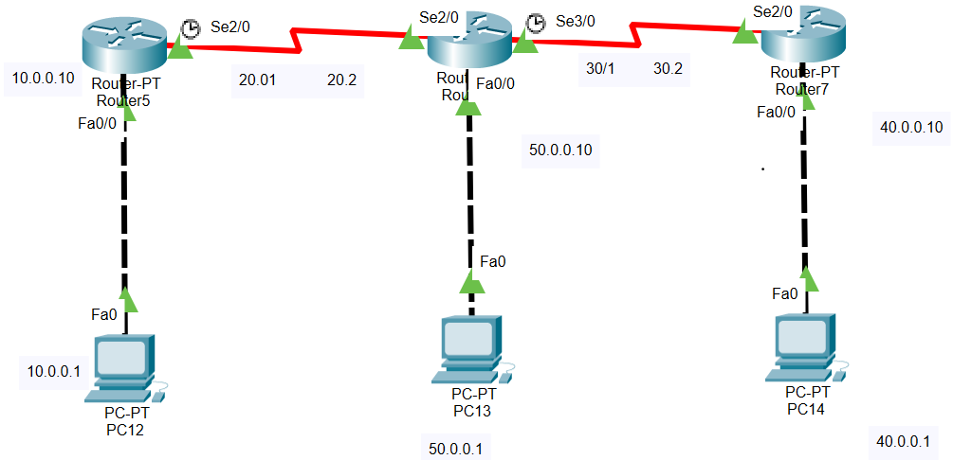
Default commands for Topology .

R1 , R2 , R3 -

R1
Conf ter
interface fastEthernet 0/0
no sh
ip address 10.0.0.10 255.0.0.0
exi
hostname R1
interface serial 2/0
ip address 20.0.0.1 255.0.0.0
no sh
exi

R2

Conf ter
hostname R2
interface serial 2/0
no sh
ip address 20.0.0.2 255.0.0.0
no sh
exi
interface serial 3/0
ip address 30.0.0.2 255.0.0.0
no sh
exi
interface fastEthernet 0/0
ip address 50.0.0.10 255.0.0.0
no sh
exi

R3

Conf ter
hostname R3
interface serial 2/0
ip address 30.0.0.3 255.0.0.0
no sh
exi
interface fastEthernet 0/0
no sh
ip address 40.0.0.10 255.0.0.0
no sh
exi

R1
router eigrp 100
network 20.0.0.0 0.255.255.255
network 10.0.0.0 0.255.255.255
No auto
exi

R2

router eigrp 100
network 20.0.0.0 0.255.255.255
network 30.0.0.0 0.255.255.255
network 40.0.0.0 0.255.255.255
No auto
exi

R3
router eigrp 100
network 30.0.0.0 0.255.255.255
network 40.0.0.0 0.255.255.255
NO auto
exi

No auto summary – LAB EIGRP

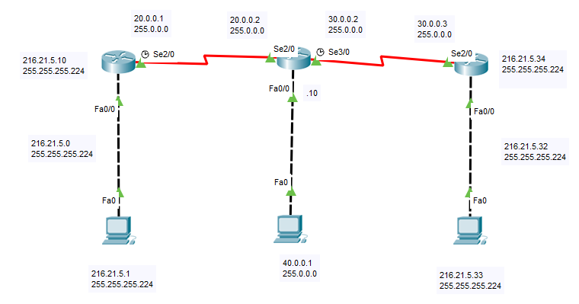
216.21.5.0 – 5 networks.

R1

hostname R1
interface fastEthernet 0/0
ip address 216.21.5.10 255.255.255.224
no sh
exi
interface serial 2/0
ip address 20.0.0.1 255.0.0.0
no sh
exi

router eigrp 100
network 20.0.0.0
network 216.21.5.0 0.0.0.31
exi

R2
hostname R2
interface fastEthernet 0/0
ip address 40.0.0.10 255.0.0.0
no sh
exi
interface serial 2/0
ip address 20.0.0.2 255.0.0.0
no sh
exi
interface serial 3/0
no sh
ip address 30.0.0.2 255.0.0.0
no sh
exi

router eigrp 100
network 20.0.0.0 0.255.255.255
network 30.0.0.0 0.255.255.255
network 40.0.0.0 0.255.255.255
exi

R3

interface fastEthernet 0/0
ip address 216.21.5.34 255.255.255.224
no sh
exi
interface serial 2/0
ip address 30.0.0.3 255.0.0.0
no sh
exi

router eigrp 100
network 30.0.0.0 0.255.255.255
network 216.21.5.32 0.0.0.31
exi

OSPF LAB

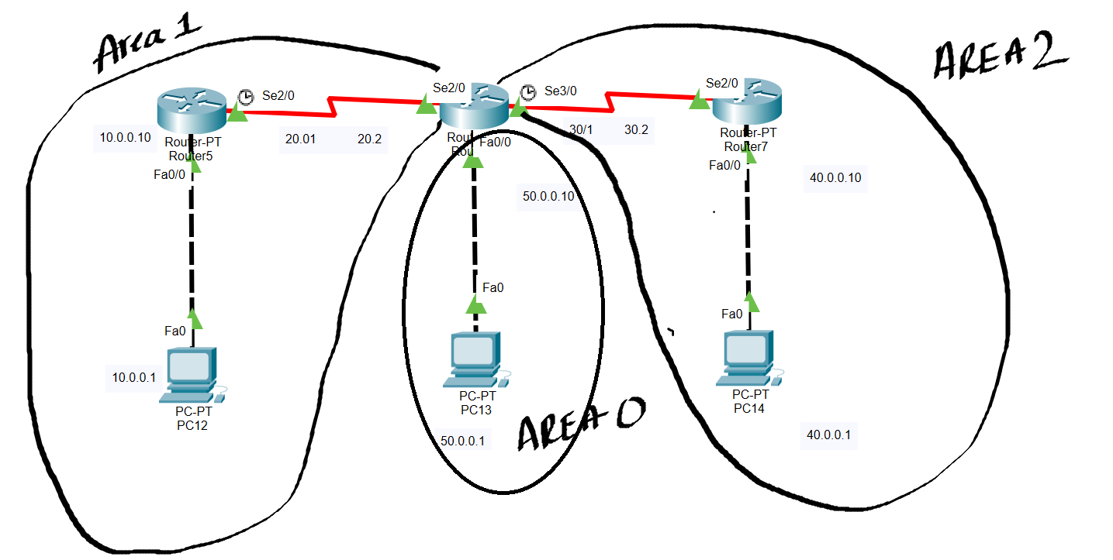

R1
router ospf 10
network 10.0.0.0 0.255.255.255 area 1
network 20.0.0.0 0.255.255.255 area 1
Exit

R2
router ospf 10
network 20.0.0.0 0.255.255.255 area 1
network 30.0.0.0 0.255.255.255 area 2
network 50.0.0.0 0.255.255.255 area 0
Exit

R3
router ospf 10
network 30.0.0.0 0.255.255.255 area 2
network 40.0.0.0 0.255.255.255 area 2
Exit

DR and BDR LAB

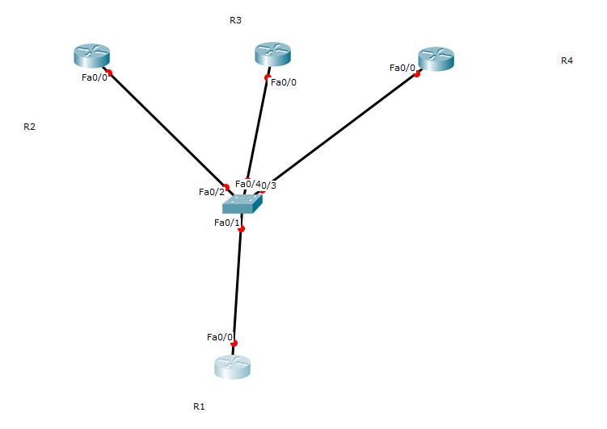
hostname R1
interface fastEthernet 0/0
no shutdown
ip address 10.0.0.1 255.0.0.0
exi

hostname R2
interface fastEthernet 0/0
ip address 10.0.0.2 255.0.0.0
no sh
exi

hostname R3
interface fastEthernet 0/0
no shutdown
ip address 10.0.0.3 255.0.0.0
exi

hostname R4
interface fastEthernet 0/0
ip address 10.0.0.4 255.0.0.0
no sh
exi

router ospf 10
network 10.0.0.0 0.255.255.255 area 0
end
In all routers

Show ip ospf Neighbours
R1(config)#interface fastEthernet 0/0
R1(config-if)#ip ospf priority 200
You change the priority if you like by using the ip ospf priority command:
- The default priority is 1.
- A priority of 0 means you will never be elected as DR or BDR.
You need to use clear ip ospf process before this change takes effect.
we need to reset the OSPF neighbor adjacencies so that we’ll elect the new DR and BDR.
#clear ip ospf process
Reset ALL OSPF processes? [no]: yes
#clear ip ospf process
Reset ALL OSPF processes? [no]: yes
I’ll reset all the OPSF neighbor adjacencies.

R1#show ip ospf interface fastEthernet 0/0

Acl

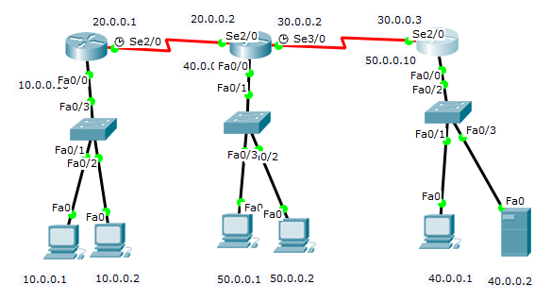
TASK
- Deny host 10.0.0.1 from communicating with 50.0.0.0 – Numbered and named both.
- Deny host 50.0.0.2 from communicating with 50.0.0.0

hostname R1
interface fastEthernet 0/0
ip address 10.0.0.10 255.0.0.0
no shutdown
exi
interface serial 2/0
ip address 20.0.0.1 255.0.0.0
no shutdown
exi
router eigrp 100
network 10.0.0.0
network 20.0.0.0
no auto-summary
exi

hostname R2
interface fastEthernet 0/0
ip address 50.0.0.10 255.0.0.0
no sh
exi
interface serial 2/0
ip address 20.0.0.02 255.0.0.0
no sh
exi
interface serial 3/0
ip address 30.0.0.2 255.0.0.0
no sh
exi
router eigrp 100
network 20.0.0.0
network 30.0.0.0
network 50.0.0.0
no auto-summary
exi

hostname R3
interface fastEthernet 0/0
ip address 40.0.0.10 255.0.0.0
no sh
exi
interface serial 2/0
ip address 30.0.0.3 255.0.0.0
no sh
exi
router eigrp 100
no auto-summary
network 30.0.0.0
network 40.0.0.0
exi
R2 - Numbered
conf t
access-list 10 deny 10.0.0.1
access-list 10 deny 50.0.0.2
access-list 10 permit any

interface fastEthernet 0/0
ip access-group 10 out
exi

After configuring remove seq number 20 by giving “no access-list 10 deny 40.0.0.2”

R2-Named – Without permit any.

ip access-list standard cisco
deny host 10.0.0.1
deny host 50.0.0.2
exi
interface fastEthernet 0/0
ip access-group cisco out
exi

After configuring remove seq number 20 by giving “no deny host 40.0.0.2”

Task
- Deny the user 10.0.0.1 should not access 40.0.0.2 http service
- Deny the user 10.0.0.2 should not be able to use ICMP to 40.0.0.2 ping service .

R1
access-list 100 deny tcp 10.0.0.1 0.0.0.0 host 40.0.0.2 eq www
access-list 100 deny icmp 10.0.0.2 0.0.0.0 host 40.0.0.2 echo
access-list 100 permit ip any any
interface fastEthernet 0/0
ip access-group 100 in
exi

R2
ip access-list extended cisco
deny tcp host 10.0.0.1 host 40.0.0.2 eq www
deny icmp host 10.0.0.2 host 40.0.0.2 echo
permit ip any any
exi
interface FastEthernet0/0
ip address 10.0.0.10 255.0.0.0
ip access-group cisco in
exit

NATTING

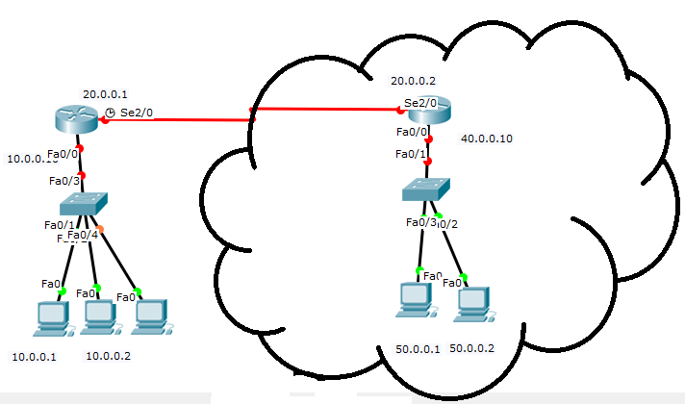

hostname R1
interface fastEthernet 0/0
ip address 10.0.0.10 255.0.0.0
no shutdown
exi
interface serial 2/0
ip address 20.0.0.1 255.0.0.0
no shutdown
exi

hostname R2
interface fastEthernet 0/0
ip address 50.0.0.10 255.0.0.0
no sh
exi
interface serial 2/0
ip address 20.0.0.02 255.0.0.0
no sh
exi
interface serial 3/0
ip address 30.0.0.2 255.0.0.0
no sh
exi

R1
ip route 0.0.0.0 0.0.0.0 20.0.0.2

R2
ip route 70.0.0.0 255.0.0.0 20.0.0.1

R1 – Static nat
ip nat inside source static 10.0.0.1 70.0.0.1
ip nat inside source static 10.0.0.2 70.0.0.2
exi
interface fastEthernet 0/0
ip nat inside
exi
interface serial 2/0
ip nat outside
exi

R1 – Dynamic nat

access-list 55 permit 10.0.0.0 0.255.255.255
ip nat pool ccna 70.0.0.1 70.0.0.10 netmask 255.0.0.0
ip nat inside source list 55 pool ccna

R1 – Overload nat / PAT

access-list 55 permit 10.0.0.0 0.255.255.255
ip nat pool ccna 70.0.0.1 70.0.0.1 netmask 255.255.255.255
ip nat inside source list 55 pool ccna overload

IPV6

Static routing
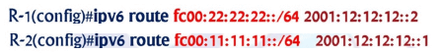

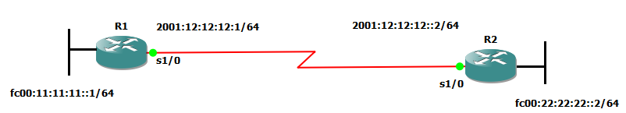

interface serial 1/0
ipv6 address 2001:12:12:12::1/64
no sh
exi

interface serial 1/1
ipv6 address fc00:11:11:11::1/64
no sh
no keepalive
exi

ipv6 route FC00:22:22:22::/64 2001:12:12:12::2
exi

R2

interface serial 1/0
ipv6 address 2001:12:12:12::2/64
no sh
exi

interface serial 1/1
ipv6 address fc00:22:22:22::2/64
no sh
no keepalive
exi

ipv6 route FC00:11:11:11::/64 2001:12:12:12::1
exi

IPV6 Dynamic routing

IPV6 routing types – Static , RIP ng , OSPF V3 , EIGRP – IPV6 unicast routing
Static routing




interface serial 1/0
ipv6 address 2001:12:12:12::1/64
no sh
exi

interface serial 1/1
ipv6 address fc00:11:11:11::1/64
no sh
no keepalive
exi

ipv6 route FC00:22:22:22::/64 2001:12:12:12::2
exi

R2

interface serial 1/0
ipv6 address 2001:12:12:12::2/64
no sh
exi

interface serial 1/1
ipv6 address fc00:22:22:22::2/64
no sh
no keepalive
exi

ipv6 route FC00:11:11:11::/64 2001:12:12:12::1
exi

***************************

EIGRP Lab Packet tracer lab

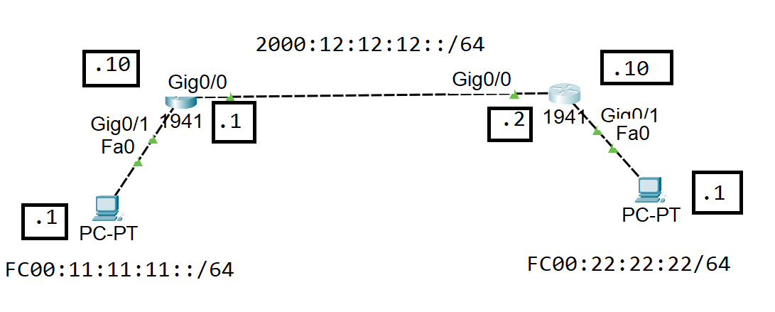

hostname RTR1

interface gigabitEthernet 0/1
no shutdown
ipv6 address fc00:11:11:11::10/64
exit
interface gigabitEthernet 0/0
no shutdown
ipv6 address 2000:12:12:12::1/64
no shutdown
exit

ipv6 unicast-routing
ipv6 router eigrp 100
eigrp router-id 2.2.2.2
no shutdown
exit

interface gigabitEthernet 0/0
ipv6 eigrp 100
exit
interface gigabitEthernet 0/1
ipv6 eigrp 100
exit

R2

R2
hostname RTR1

interface gigabitEthernet 0/0
no shutdown
ipv6 address fc00:22:22:22::10/64
exit
interface gigabitEthernet 0/1
no shutdown
ipv6 address 2000:12:12:12::2/64
no shutdown
exit

ipv6 unicast-routing
ipv6 router eigrp 100
eigrp router-id 1.1.1.1
no shutdown
exit

interface gigabitEthernet 0/0
ipv6 eigrp 100
exit
interface gigabitEthernet 0/1
ipv6 eigrp 100
exit

-----------------END OF EIGRP-----------------

RIP ng Packet tracer lab

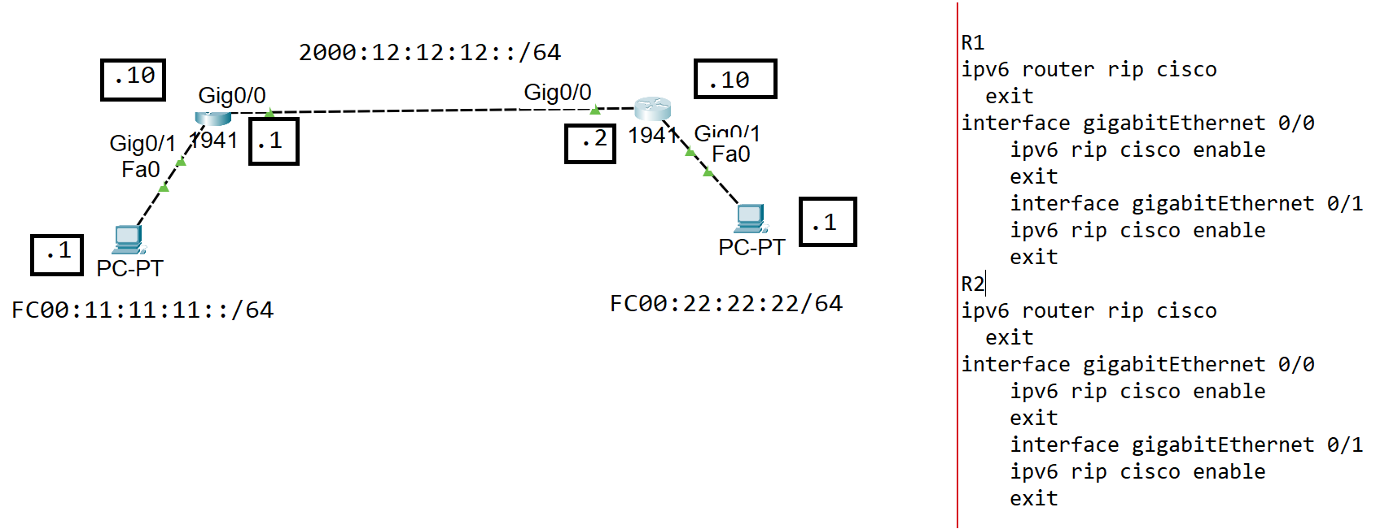
R1
ipv6 router rip cisco
exit
interface gigabitEthernet 0/0
ipv6 rip cisco enable
exit
interface gigabitEthernet 0/1
ipv6 rip cisco enable
exit
R2
ipv6 router rip cisco
exit
interface gigabitEthernet 0/0
ipv6 rip cisco enable
exit
interface gigabitEthernet 0/1
ipv6 rip cisco enable
exit

Summarization with EIGRP
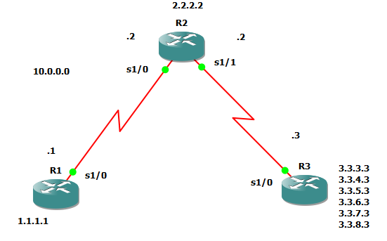
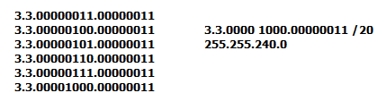
R1
interface loopback 1
ip address 1.1.1.1 255.255.255.255
exi
interface fa 0/0
ip address 10.0.0.1 255.255.255.0
no sh
exi

R2
interface fa 0/0
ip address 10.0.0.2 255.255.255.0
no shutdown
exi
interface fa 0/1
ip address 20.0.0.2 255.255.255.0
no shutdown
exi
interface loopback 2
ip address 2.2.2.2 255.255.255.255
exi

R3
interface fa 0/0
no sh
ip address 20.0.0.3 255.255.255.0
exi
interface loopback 1
ip address 3.3.3.3 255.255.255.0
exi
interface loopback 2
ip address 3.3.4.3 255.255.255.0
exi
interface loopback 3
ip address 3.3.5.3 255.255.255.0
exi
interface loopback 4
ip address 3.3.6.3 255.255.255.0
exi
interface loopback 5
ip address 3.3.7.3 255.255.255.0
exi
interface loopback 6
ip address 3.3.7.3 255.255.255.0
exi
interface loopback 6
ip address 3.3.8.3 255.255.255.0
exi

R1
router eigrp 100
network 1.0.0.0
network 10.0.0.0
no auto
exi

R2
router eigrp 100
network 10.0.0.0
network 20.0.0.0
network 2.0.0.0
no auto

exi

R3
router eigrp 100
network 20.0.0.0
network 3.0.0.0
no auto

exi

In R2 show ip route before giving No autosummary
D 1.0.0.0/8 [90/2297856] via 10.0.0.1, 00:00:55, Serial1/0
2.0.0.0/8 is variably subnetted, 2 subnets, 2 masks
C 2.2.2.2/32 is directly connected, Loopback2
D 2.0.0.0/8 is a summary, 00:00:45, Null0
D 3.0.0.0/8 [90/2297856] via 20.0.0.3, 00:00:18, Serial1/1
20.0.0.0/8 is variably subnetted, 2 subnets, 2 masks
C 20.0.0.0/24 is directly connected, Serial1/1
D 20.0.0.0/8 is a summary, 00:00:52, Null0
10.0.0.0/8 is variably subnetted, 2 subnets, 2 masks
C 10.0.0.0/24 is directly connected, Serial1/0
D 10.0.0.0/8 is a summary, 00:00:52, Null0

In R2 show ip route after giving No autosummary

D 1.0.0.0/8 [90/2297856] via 10.0.0.1, 00:01:55, Serial1/0
2.0.0.0/32 is subnetted, 1 subnets
C 2.2.2.2 is directly connected, Loopback2
3.0.0.0/24 is subnetted, 6 subnets
D 3.3.3.0 [90/2297856] via 20.0.0.3, 00:00:33, Serial1/1
D 3.3.4.0 [90/2297856] via 20.0.0.3, 00:00:33, Serial1/1
D 3.3.5.0 [90/2297856] via 20.0.0.3, 00:00:33, Serial1/1
D 3.3.6.0 [90/2297856] via 20.0.0.3, 00:00:33, Serial1/1
D 3.3.7.0 [90/2297856] via 20.0.0.3, 00:00:33, Serial1/1
D 3.3.8.0 [90/2297856] via 20.0.0.3, 00:00:33, Serial1/1
20.0.0.0/24 is subnetted, 1 subnets
C 20.0.0.0 is directly connected, Serial1/1
10.0.0.0/24 is subnetted, 1 subnets

R3

interface fa 0/0
ip summary-address eigrp 100 3.3.0.0 255.255.240.0
exit
After this command

R2
Show ip route
Gateway of last resort is not set

D 1.0.0.0/8 [90/2297856] via 10.0.0.1, 00:14:46, Serial1/0
2.0.0.0/32 is subnetted, 1 subnets
C 2.2.2.2 is directly connected, Loopback2
3.0.0.0/20 is subnetted, 1 subnets
D 3.3.0.0 [90/2297856] via 20.0.0.3, 00:00:24, Serial1/1
20.0.0.0/24 is subnetted, 1 subnets
C 20.0.0.0 is directly connected, Serial1/1
10.0.0.0/24 is subnetted, 1 subnets
C 10.0.0.0 is directly connected, Serial1/0
R2#

Authentication - EIGRP
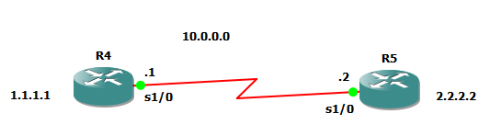

R4
interface loopback 1
ip address 1.1.1.1 255.255.255.255
no sh
exi
interface fa 0/0
ip address 10.0.0.1 255.0.0.0
no sh
exi
router eigrp 100
network 1.0.0.0
network 10.0.0.0
no auto-summary
exi

R5
interface loopback 2
ip address 2.2.2.2 255.255.255.255
exi
interface fa 0/0
ip address 10.0.0.2 255.0.0.0
no sh
exi
router eigrp 100
network 2.0.0.0
network 10.0.0.0
no auto-summary
exit

First we need to create the Key chain - Using the Key-string and Key Number it will create a hash value which has match on both sides. Key chain has to be same on both the routers .
R4
key chain R1
key 20
key-string cisco
exi
interface fa 0/0
ip authentication mode eigrp 100 md5
ip authentication key-chain eigrp 100 R1
exi

Show ip route
R5
key chain R1
key 20
key-string cisco
exi
interface fa 0/0
ip authentication mode eigrp 100 md5
ip authentication key-chain eigrp 100 R1
exi
Show ip route

Routing information protocol – Authentication
R4
key chain R2
key 20
key-string cisco
exi
interface fa 0/0
ip rip authentication mode md5
ip rip authentication key-chain R2
exi
R5
key chain R2
key 20
key-string cisco
exi
interface fa 0/0
ip rip authentication mode md5
ip rip authentication key-chain R2
exi

OSPF Authentication

r1

router ospf 10
network 10.0.0.0 0.255.255.255 area 0
network 1.1.1.1 0.0.0.0 area 0
exi

r2

router ospf 10
network 2.0.0.0 0.0.0.0 area 0
network 10.0.0.0 0.255.255.255 area 0
exi

r1
interface fa 0/0
ip ospf authentication message-digest
ip ospf message-digest-key 5 md5 cisco
exi

r2

interface fa 0/0
ip ospf authentication message-digest
ip ospf message-digest-key 2 md5 cisco
end

Redistribution
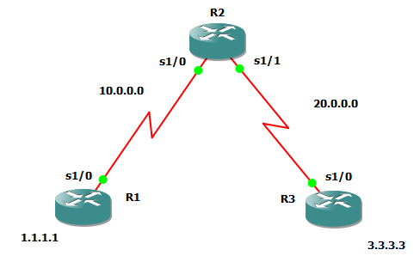
R1
interface loopback 1
ip address 1.1.1.1 255.255.255.255
no sh
exi

interface serial 1/0
no sh
ip address 10.0.0.1 255.0.0.0
exi

router rip
version 2
network 1.0.0.0
no auto-summary
network 10.0.0.0
exi

R2
interface serial 1/0
ip address 10.0.0.2 255.0.0.0
no sh
exi

interface serial 1/1
ip address 20.0.0.2 255.0.0.0
no sh
exi

router rip
version 2
no auto
network 10.0.0.0

router eigrp 100
network 20.0.0.0
no auto-summary
exi

R3

interface serial 1/0
no sh
ip address 20.0.0.3 255.0.0.0
exi

interface loopback 3
ip address 3.3.3.3 255.255.255.255
exi

router eigrp 100
network 3.0.0.0
no auto-summary
network 20.0.0.0
exi

Show ip route

R2
router rip
redistribute eigrp 100 metric 3
exi

router eigrp 100
redistribute rip metric 1000 2000 255 1 1500
exi

Show ip route

R1

router rip
version 2
network 1.0.0.0
no auto-summary
network 10.0.0.0
exi

R2

router rip
version 2
no auto
network 10.0.0.0
exit

router ospf 10
network 20.0.0.0 0.255.255.255 area 0
exi

R3
router ospf 100
network 20.0.0.0 0.255.255.255 area 0
network 3.3.3.3 0.0.0.0 area 0
exit

R2
router rip
redistribute ospf 10 metric 5
exi
Classfull
router ospf 10
redistribute rip
exi
Classless
router ospf 10
redistribute rip subnets
exi

Show ip route
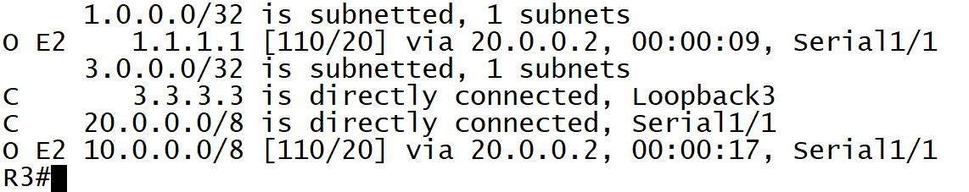

In OSPF there is no need to explicitly mention the metric cost like other protocols because in OSPF all redistributed external routes will have a default cost of 20

router ospf 10
redistribute rip subnets metric 100
exi
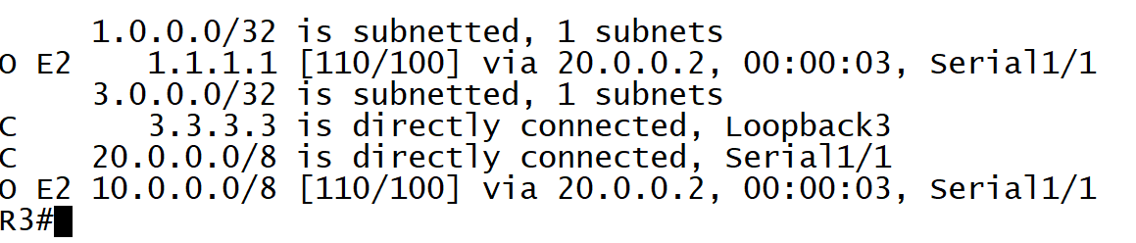

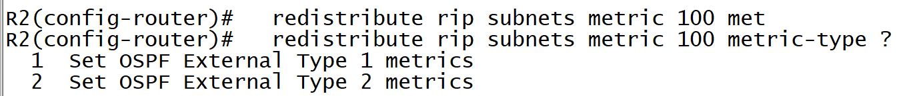

Type 2 will add cost of 100 for all routers path cost
But Type 1 will also add the indivisual cost along with 100

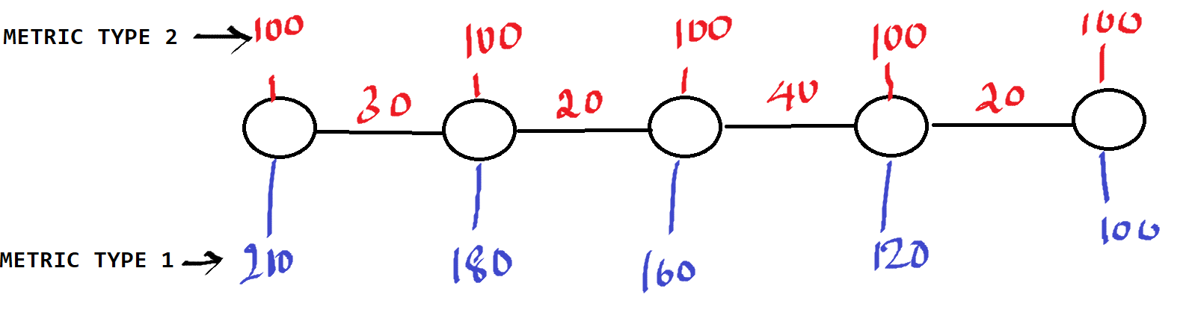

router ospf 10
redistribute rip subnets metric 100 metric-type 1
exi
NOTE: Metric and Metric type are optional Baceuse by default ospf takes all external routes metric as 20 . In R3 show ip route ospf .
If we don’t give “ SUBNETS “ command by default OSPF will only redistribute classfull networks ,

Show ip route

Summarization with EIGRP


R1
interface loopback 1
ip address 1.1.1.1 255.255.255.255
exi
interface fa 0/0
ip address 10.0.0.1 255.255.255.0
no sh
exi

R2
interface fa 0/0
ip address 10.0.0.2 255.255.255.0
no shutdown
exi
interface fa 0/1
ip address 20.0.0.2 255.255.255.0
no shutdown
exi
interface loopback 2
ip address 2.2.2.2 255.255.255.255
exi

R3
interface fa 0/0
no sh
ip address 20.0.0.3 255.255.255.0
exi
interface loopback 1
ip address 3.3.3.3 255.255.255.0
exi
interface loopback 2
ip address 3.3.4.3 255.255.255.0
exi
interface loopback 3
ip address 3.3.5.3 255.255.255.0
exi
interface loopback 4
ip address 3.3.6.3 255.255.255.0
exi
interface loopback 5
ip address 3.3.7.3 255.255.255.0
exi
interface loopback 6
ip address 3.3.7.3 255.255.255.0
exi
interface loopback 6
ip address 3.3.8.3 255.255.255.0
exi

R1
router eigrp 100
network 1.0.0.0
network 10.0.0.0
no auto
exi

R2
router eigrp 100
network 10.0.0.0
network 20.0.0.0
network 2.0.0.0
no auto

exi

R3
router eigrp 100
network 20.0.0.0
network 3.0.0.0
no auto

exi

In R2 show ip route before giving No autosummary
D 1.0.0.0/8 [90/2297856] via 10.0.0.1, 00:00:55, Serial1/0
2.0.0.0/8 is variably subnetted, 2 subnets, 2 masks
C 2.2.2.2/32 is directly connected, Loopback2
D 2.0.0.0/8 is a summary, 00:00:45, Null0
D 3.0.0.0/8 [90/2297856] via 20.0.0.3, 00:00:18, Serial1/1
20.0.0.0/8 is variably subnetted, 2 subnets, 2 masks
C 20.0.0.0/24 is directly connected, Serial1/1
D 20.0.0.0/8 is a summary, 00:00:52, Null0
10.0.0.0/8 is variably subnetted, 2 subnets, 2 masks
C 10.0.0.0/24 is directly connected, Serial1/0
D 10.0.0.0/8 is a summary, 00:00:52, Null0

In R2 show ip route after giving No autosummary

D 1.0.0.0/8 [90/2297856] via 10.0.0.1, 00:01:55, Serial1/0
2.0.0.0/32 is subnetted, 1 subnets
C 2.2.2.2 is directly connected, Loopback2
3.0.0.0/24 is subnetted, 6 subnets
D 3.3.3.0 [90/2297856] via 20.0.0.3, 00:00:33, Serial1/1
D 3.3.4.0 [90/2297856] via 20.0.0.3, 00:00:33, Serial1/1
D 3.3.5.0 [90/2297856] via 20.0.0.3, 00:00:33, Serial1/1
D 3.3.6.0 [90/2297856] via 20.0.0.3, 00:00:33, Serial1/1
D 3.3.7.0 [90/2297856] via 20.0.0.3, 00:00:33, Serial1/1
D 3.3.8.0 [90/2297856] via 20.0.0.3, 00:00:33, Serial1/1
20.0.0.0/24 is subnetted, 1 subnets
C 20.0.0.0 is directly connected, Serial1/1
10.0.0.0/24 is subnetted, 1 subnets

R3

interface fa 0/0
ip summary-address eigrp 100 3.3.0.0 255.255.240.0
exit
After this command

R2
Show ip route
Gateway of last resort is not set

D 1.0.0.0/8 [90/2297856] via 10.0.0.1, 00:14:46, Serial1/0
2.0.0.0/32 is subnetted, 1 subnets
C 2.2.2.2 is directly connected, Loopback2
3.0.0.0/20 is subnetted, 1 subnets
D 3.3.0.0 [90/2297856] via 20.0.0.3, 00:00:24, Serial1/1
20.0.0.0/24 is subnetted, 1 subnets
C 20.0.0.0 is directly connected, Serial1/1
10.0.0.0/24 is subnetted, 1 subnets
C 10.0.0.0 is directly connected, Serial1/0
R2#

Authentication - EIGRP


R4
interface loopback 1
ip address 1.1.1.1 255.255.255.255
no sh
exi
interface fa 0/0
ip address 10.0.0.1 255.0.0.0
no sh
exi
router eigrp 100
network 1.0.0.0
network 10.0.0.0
no auto-summary
exi

R5
interface loopback 2
ip address 2.2.2.2 255.255.255.255
exi
interface fa 0/0
ip address 10.0.0.2 255.0.0.0
no sh
exi
router eigrp 100
network 2.0.0.0
network 10.0.0.0
no auto-summary
exit

First we need to create the Key chain - Using the Key-string and Key Number it will create a hash value which has match on both sides. Key chain has to be same on both the routers .
R4
key chain R1
key 20
key-string cisco
exi
interface fa 0/0
ip authentication mode eigrp 100 md5
ip authentication key-chain eigrp 100 R1
exi

Show ip route
R5
key chain R1
key 20
key-string cisco
exi
interface fa 0/0
ip authentication mode eigrp 100 md5
ip authentication key-chain eigrp 100 R1
exi
Show ip route

Routing information protocol – Authentication
R4
key chain R2
key 20
key-string cisco
exi
interface fa 0/0
ip rip authentication mode md5
ip rip authentication key-chain R2
exi
R5
key chain R2
key 20
key-string cisco
exi
interface fa 0/0
ip rip authentication mode md5
ip rip authentication key-chain R2
exi

OSPF Authentication

r1

router ospf 10
network 10.0.0.0 0.255.255.255 area 0
network 1.1.1.1 0.0.0.0 area 0
exi

r2

router ospf 10
network 2.0.0.0 0.0.0.0 area 0
network 10.0.0.0 0.255.255.255 area 0
exi

r1
interface fa 0/0
ip ospf authentication message-digest
ip ospf message-digest-key 5 md5 cisco
exi

r2

interface fa 0/0
ip ospf authentication message-digest
ip ospf message-digest-key 2 md5 cisco
end

Redistribution

R1
interface loopback 1
ip address 1.1.1.1 255.255.255.255
no sh
exi

interface serial 1/0
no sh
ip address 10.0.0.1 255.0.0.0
exi

router rip
version 2
network 1.0.0.0
no auto-summary
network 10.0.0.0
exi

R2
interface serial 1/0
ip address 10.0.0.2 255.0.0.0
no sh
exi

interface serial 1/1
ip address 20.0.0.2 255.0.0.0
no sh
exi

router rip
version 2
no auto
network 10.0.0.0

router eigrp 100
network 20.0.0.0
no auto-summary
exi

R3

interface serial 1/0
no sh
ip address 20.0.0.3 255.0.0.0
exi

interface loopback 3
ip address 3.3.3.3 255.255.255.255
exi

router eigrp 100
network 3.0.0.0
no auto-summary
network 20.0.0.0
exi

Show ip route

R2
router rip
redistribute eigrp 100 metric 3
exi

router eigrp 100
redistribute rip metric 1000 2000 255 1 1500
exi

Show ip route

R3
router ospf 100
network 20.0.0.0 0.255.255.255 area 0
network 3.3.3.3 0.0.0.0 area 0
exit

R2
router ospf 10
network 20.0.0.0 0.255.255.255 area 0
exi

router rip
redistribute ospf 10 metric 5
exi

router ospf 10
redistribute rip subnets metric 100 metric-type 1
exi
NOTE: If I say “ redistribute rip - enter“ it will take classfull , Metric and Metric type are optional Baceuse by default ospf takes all external routes metric as 20 . In R3 show ip route ospf .
If we don’t give “ SUBNETS “ command by default OSPF will only redistribute classfull networks ,

Show ip route

Policy Based Routing , route map

Route MAP
Route maps are used when redistributing routes into an OSPF, RIP, or EIGRP routing process. They are also used when generating a default route into an Any routing process. A route map defines which of the routes from the specified routing protocol are allowed to be redistributed into the target routing process based on the parameters as per the requirement.
Requirement : 3.3.3.0 and 3.3.4.0 should get advertised in to OSPF with a metric value of 1000
3.3.5.0 and 3.3.6.0 should get advertised in to OSPF with a metric value of 2000
3.3.7.0 and 3.3.8.0 should get advertised in to OSPF with a metric value of 3000
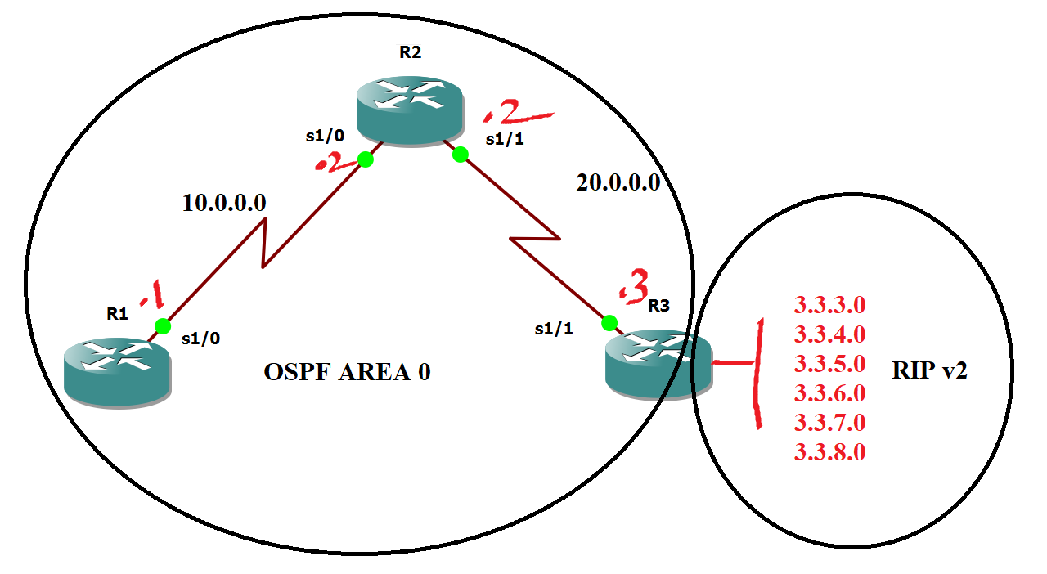

interface loopback 1
ip address 1.1.1.1 255.255.255.255
exi
interface SE 1/0
ip address 10.0.0.1 255.255.255.0
no sh
exi

R2
interface se 1/0
ip address 10.0.0.2 255.255.255.0
no shutdown
exi
interface se 1/1
ip address 20.0.0.2 255.255.255.0
no shutdown
exi
interface loopback 2
ip address 2.2.2.2 255.255.255.255
exi

R3
interface se 1/1
no sh
ip address 20.0.0.3 255.255.255.0
exi
interface loopback 1
ip address 3.3.3.3 255.255.255.0
exi
interface loopback 2
ip address 3.3.4.3 255.255.255.0
exi
interface loopback 3
ip address 3.3.5.3 255.255.255.0
exi
interface loopback 4
ip address 3.3.6.3 255.255.255.0
exi
interface loopback 5
ip address 3.3.7.3 255.255.255.0
exi
interface loopback 6
ip address 3.3.7.3 255.255.255.0
exi
interface loopback 6
ip address 3.3.8.3 255.255.255.0
exi

R1
router ospf 10
network 1.0.0.0 0.255.255.255 area 0
network 10.0.0.0 0.255.255.255 area 0
exi

R2
router ospf 100
network 10.0.0.0 0.255.255.255 area 0
network 20.0.0.0 0.255.255.255 area 0
network 2.0.0.0 0.255.255.255 area 0
exi

R3
router rip
ver 2
network 3.0.0.0
no auto
exi
router ospf 100
network 20.0.0.0 0.255.255.255 area 0
Exit

R3
router ospf 100
redistribute rip subnets metric 100 metric-type 2
exi

NOTE: A type 1 (Calculated cost) route has a metric that is the sum of the internal OSPF cost and the external redistributed cost. A type 2 (Default cost) route has a metric equal only to the redistributed cost,

1.Match the Networks
access-list 11 permit 3.3.3.0 0.0.0.255
access-list 11 permit 3.3.4.0 0.0.0.255
access-list 21 permit 3.3.5.0 0.0.0.255
access-list 21 permit 3.3.6.0 0.0.0.255
access-list 31 permit 3.3.7.0 0.0.0.255
access-list 31 permit 3.3.8.0 0.0.0.255

2.Implement Route-map
route-map CCNP permit 10
match ip address 11
set metric 1000
exit
route-map CCNP permit 20
match ip address 21
set metric 2000
exit
route-map CCNP permit 30
match ip address 31
set metric 3000
exit
3.Use route-map
router ospf 10
redistribute rip subnets route-map CCNP

64 – It will also add wan interface cost

Policy based routing
Policy based routing – Routing done based on the policies defined by the administrator. Routing will not be done based on the routing table than the routing will be done based on certain policy based on certain route map statements.
PBR will be implemented on the incoming direction of the source interface.

Requirement : 1.1.1.1 should always use 20.0.0.3 as the next hop
1.1.2.1 should always use 30.0.0.3 as the next hop

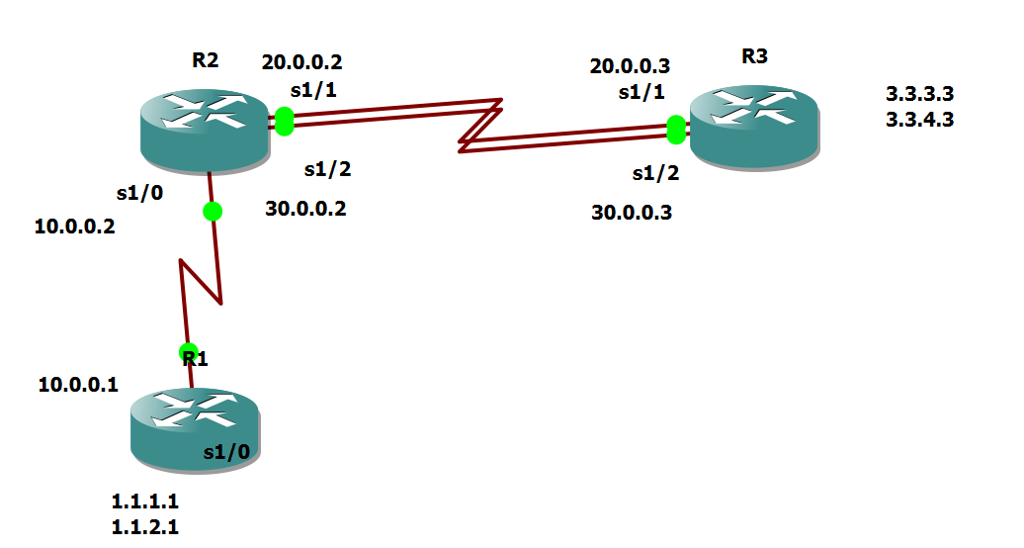

R1
interface se 1/0
no shutdown
ip address 10.0.0.1 255.0.0.0
exit
interface loopback 1
ip address 1.1.1.1 255.255.255.0
no sh
exit
interface loopback 2
ip address 1.1.2.1 255.255.255.0
no sh
exit
router eigrp 100
no auto-summary
network 1.0.0.0
network 10.0.0.0
exit
R2

interface se 1/0
no sh
ip address 10.0.0.2 255.0.0.0
exit
interface serial 1/1
no shutdown
ip address 20.0.0.2 255.0.0.0
no sh
exit
interface serial 1/2
no shutdown
ip address 30.0.0.2 255.0.0.0
exit

router eigrp 100
network 10.0.0.0
network 20.0.0.0
network 30.0.0.0
no auto-summary
exit

access-list 10 permit 1.1.1.0 0.0.0.255
access-list 11 permit 1.1.2.0 0.0.0.255

route-map CCNA permit 10
match ip address 10
set ip next-hop 20.0.0.3
exit

route-map CCNA permit 20
match ip address 11
set ip next-hop 30.0.0.3
exit

interface se 1/0
ip policy route-map CCNA
exit

R3

interface serial 1/1
ip address 20.0.0.3 255.0.0.0
no shutdown
exit

interface serial 1/2
ip address 30.0.0.3 255.0.0.0
no shutdown
exit

interface loopback 3
no shutdown
ip address 3.3.3.3 255.255.255.0
exit

router eigrp 100
network 20.0.0.0
network 30.0.0.0
no auto-summary
network 3.0.0.0

exit

Change the Bandwidth of R2 Serial 1/1 – 1000 and check the flow of traffic using Traceroute

HSRP
Hot Standby Router Protocol (HSRP) is a CISCO proprietary protocol, which provides redundancy for a local subnet. In HSRP, two or more routers gives an illusion of a virtual router.
HSRP allows you to configure two or more routers as standby routers and only a single router as an active router at a time. All the routers in a single HSRP group shares a single MAC address and IP address, which acts as a default gateway to the local network. The Active router is responsible for forwarding the traffic. If it fails, the Standby router takes up all the responsibilities of the active router and forwards the traffic.

Some important terms related to HSRP :
- Virtual IP : IP address from local subnet is assigned as default gateway to all local hosts in the network.
- Virtual MAC address : MAC address is generated automatically by HSRP. The first 24 bits will be default CISCO address (i.e. 0000.0c). The next 16 bits are HSRP ID (i.e. 07.ac). The next 8 bits will be the group number in hexadecimal. e.g- if the group number is 10 then the last 8 bits will be 0a.
Example of virtual MAC address –
0000.0c07.ac0a
- Hello messages : Periodic messages exchanged by active and standby routers. These messages are exchanged after every 3 seconds telling the state of router.
- Hold down timer : Its default value is 10 seconds i.e roughly 3 times the value of hello message. This timer tells us about the router that how much time will the standby router waits for hello message if it is not received on time.
Note : If the active router fails then the standby router will become the active router.
- Priority : By default, the priority value is 100. It is helpful when the active router comes back after falling down, we can change the priority of standby router (which has become the active router after the original active router is down) to less than 100 therefore it again becomes standby router.
Note : The router having higher priority will become the active router.
- Preempt : It is a state in which the standby router automatically becomes the active router.
- No load balancing and it supports IPV6.

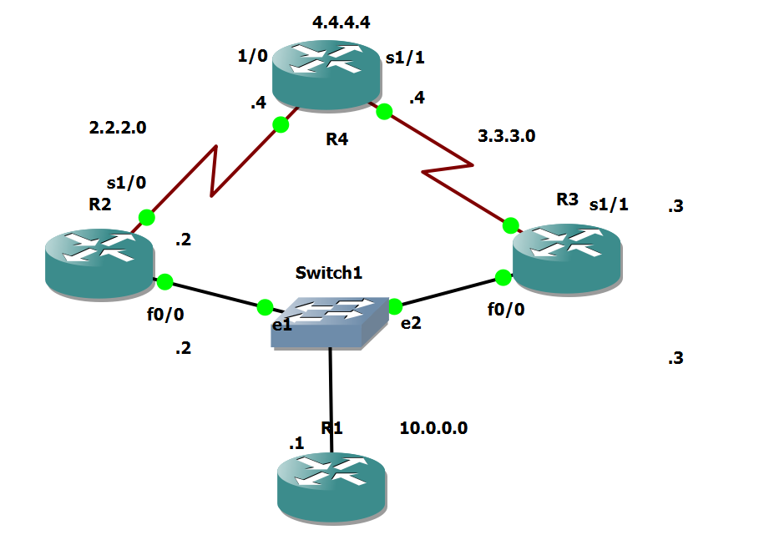

PC
interface fastEthernet 0/0
no shutdown
ip address 10.0.0.1 255.0.0.0
exit
no ip routing
ip default-gateway 10.0.0.2
ip default-gateway 10.0.0.3
ip default-gateway 10.0.0.10

R2
Interface fa0/0
No sh
ip address 10.0.0.2 255.0.0.0
exit
interface serial 2/0
ip address 2.2.2.2 255.0.0.0
no sh
exi
ip route 0.0.0.0 0.0.0.0 2.2.2.3

interface fastEthernet 0/0
standby 1 ip 10.0.0.10
standby 1 preempt

R4
interface fastEthernet 0/0
no shutdown
ip address 10.0.0.4 255.0.0.0
exit
interface serial 2/0
no shutdown
ip address 3.3.3.4 255.0.0.0
no sh
exit
ip route 0.0.0.0 0.0.0.0 3.3.3.3

interface fastEthernet 0/0
standby 1 ip 10.0.0.10
standby 1 preempt
exit

R3
interface serial 2/0
no shutdown
ip address 2.2.2.3 255.0.0.0
exit
interface serial 3/0
no shutdown
ip address 3.3.3.3 255.0.0.0
exit
interface loopback 4
ip address 4.4.4.4 255.0.0.0
exit
ip route 10.0.0.0 255.0.0.0 2.2.2.2
ip route 10.0.0.0 255.0.0.0 3.3.3.4

Password recovery .

Physical OFF and ON
CTR+SHIFT+PAUSE/BREAK (Pause/Break or equivalent command depends upon diff laptops)
Self decompressing the image :
#################################
monitor: command "boot" aborted due to user interrupt
rommon 1 > confreg 2142
rommon 2 > reset
Continue with configuration dialog? [yes/no]:no
Router>enab
Router#conf t
Router(config)#no enable password
Router(config)#no enable secret
Router#show version
Configuration register is 0x2142
Router(config)#config-register 2102
Router#reload
This time it will not ask for the password.

ROUTER IOS RESTORE

IP_ADDRESS: The IP address for this unit – Router IP address
IP_SUBNET_MASK: The subnet mask for this unit – Subnet mask of the router
DEFAULT_GATEWAY: The default gateway for this unit - Router IP address
TFTP_SERVER: The IP address of the server to fetch from – Server IP address
TFTP_FILE: The filename to fetch – Image file
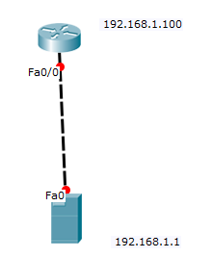
TFTPDNLD

IP_ADDRESS=192.168.1.100
IP_SUBNET_MASK=255.255.255.0
DEFAULT_GATEWAY=192.168.1.100
TFTP_SERVER=192.168.1.1
TFTP_FILE=pt1000-i-mz.122-28.bin
TFTPDNLD

Do you wish to continue - Yes
Reset

Troubleshooting connectivity.
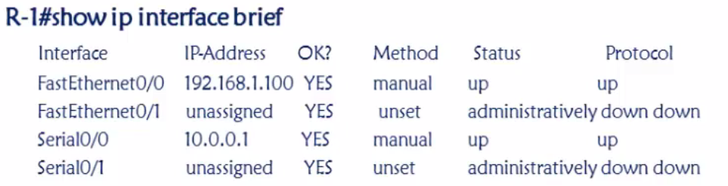

PPP –
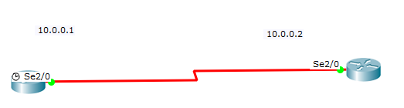
CHAP Configuration

Show interfaces serial 2/0

hostname R1
interface serial 2/0
ip address 10.0.0.1 255.0.0.0
no sh
exi

interface serial 2/0
encapsulation ppp
ppp authentication chap
exi
exi
username R2 password cisco

hostname R2
interface serial 2/0
ip address 10.0.0.2 255.0.0.0
no sh
exi

interface serial 2/0
encapsulation ppp
ppp authentication chap
exi
exi
username R1 password cisco

PAP Configuration

Show interfaces serial 2/0

interface serial 2/0
encapsulation ppp
ppp authentication pap
ppp pap sent-username R1 password cisco
exi
username R2 password cisco

interface serial 2/0
encapsulation ppp
ppp authentication pap
ppp pap sent-username R2 password cisco
exi
username R1 password cisco

Significance of Clock Rate
When you set the clock rate for a serial interface, you are setting the speed of the interface, in other words, the bandwidth (bandwidth meaning rate of data transfer). When using this command it's in the form of bits: 64000 bits = 64 kb

Router#show controllers serial 2/0
Interface Serial2/0
Hardware is PowerQUICC MPC860
DCE V.35, no clock
interface serial 2/0
clock rate 2400

CCNA SWITCH
Assigning IP address to a Switch

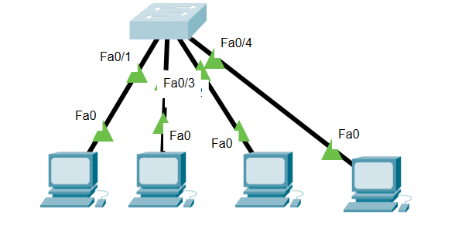
Show Vlan
interface vlan 1
no shutdown
ip address 10.0.0.100 255.0.0.0
exit

SHOW MAC-ADDRESS TABLE
SHOW VLAN
CREATING VLANS
vlan 10
name SALES
exit
vlan 20
name MANAGT
exit
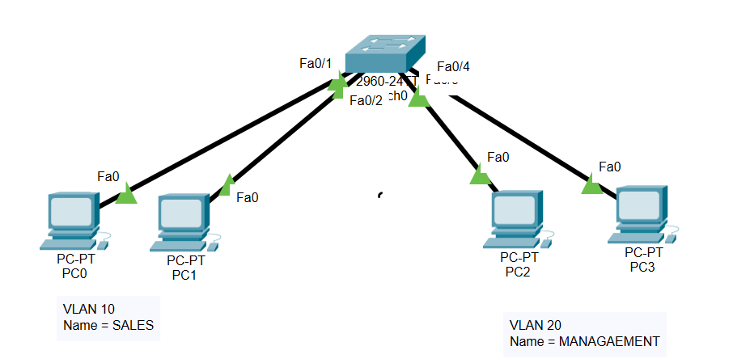
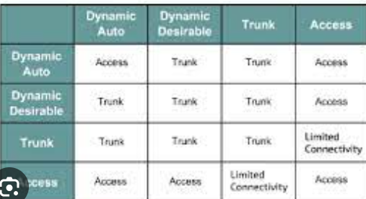
SHOW INTERfaces FAStEthernet 0/20 switchport
Which mode the switch port is in. – Dynamic Auto

Adding a port in to a Vlan
interface fastEthernet 0/1
switchport mode access
switchport access vlan 10
exit
interface fastEthernet 0/2
switchport mode access
switchport access vlan 10
exit
interface fastEthernet 0/3
switchport mode access
switchport access vlan 20
exit
interface fastEthernet 0/4
switchport mode access
switchport access vlan 20
exit

interface range fastEthernet 0/1 , fastEthernet 0/3 , fastEthernet 0/5

interface range fastEthernet 0/1 – 2
TWO DEVICES BELONGING TO TWO DIFFERENT NETWORKS CAN NEVER EVER COMMUNICATE - UNTIL AND UNLESS -L3 DEVICE

CONFIGURING TRUNK

interface fastEthernet 0/5
switchport mode trunk
exit

Switch#show interfaces trunk

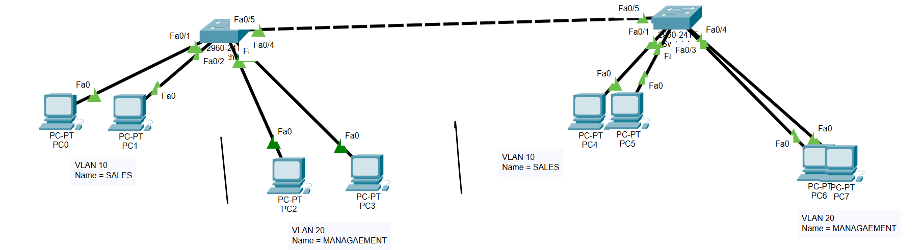

Assigning IP address to a switch
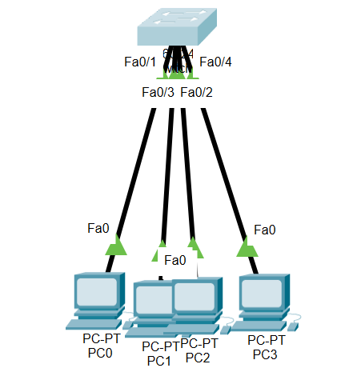
interface vlan 1
no shutdown
ip address 10.0.0.10 255.0.0.0
exi
Inter vlan routing
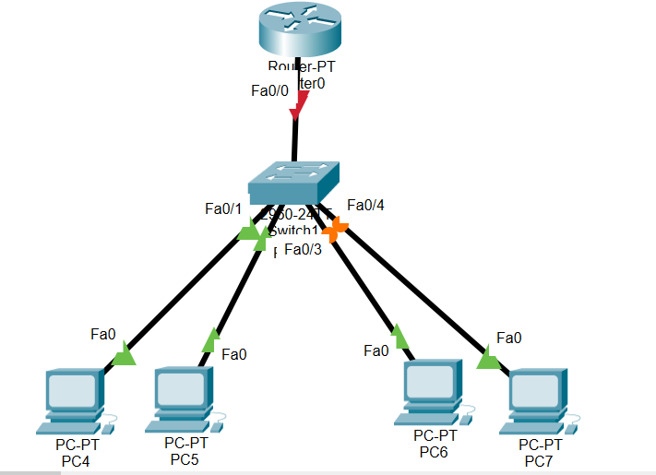

SWITCH
interface range fastEthernet 0/1 - 2
switchport mode access
switchport access vlan 10
interface range fastEthernet 0/3 - 4
switchport mode access
switchport access vlan 20
interface fastEthernet 0/5
switchport mode trunk
exit

Router
interface fastEthernet 0/0.2
encapsulation dot1Q 10
ip address 10.0.0.10 255.0.0.0
exit
interface fastEthernet 0/0.2
encapsulation dot1Q 20
ip address 20.0.0.10 255.0.0.0
exit

Difference between L3 switch and a router

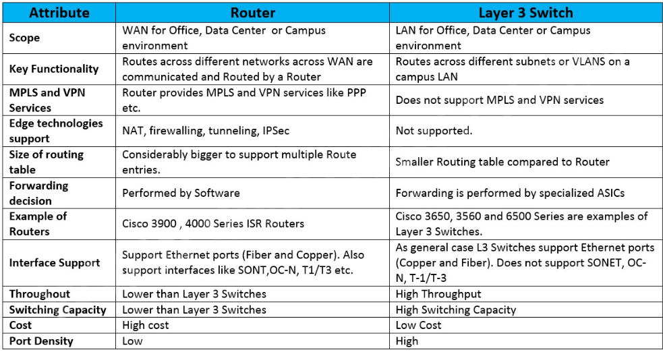

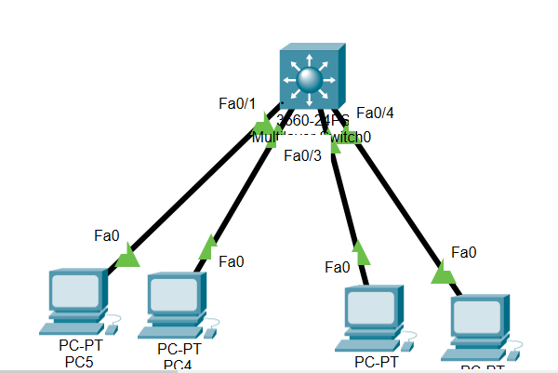

ip routing
exit
interface range fastEthernet 0/1 - 2
switchport mode access
switchport access vlan 10
exit
interface range fastEthernet 0/3 - 4
switchport mode access
switchport access vlan 20
interface vlan 10
ip address 10.0.0.10 255.0.0.0
exit
interface vlan 20
ip address 20.0.0.10 255.0.0.0
exit

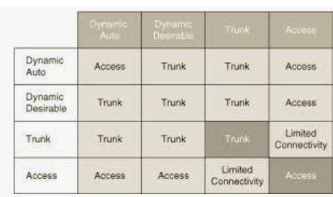
DTP modes
VTP
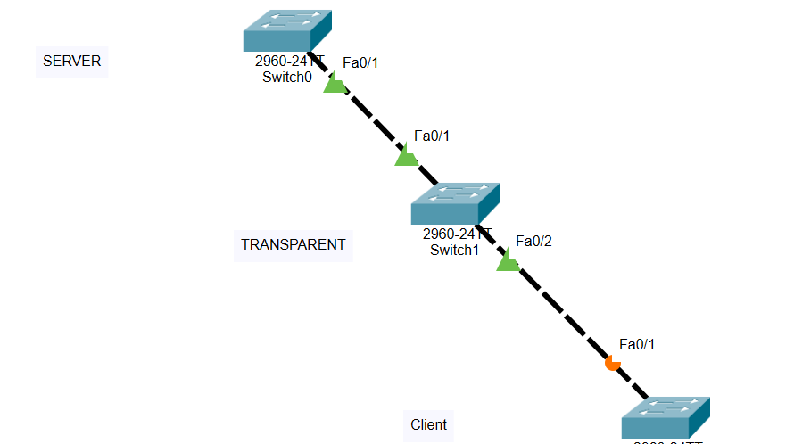
SW1
interface fastEthernet 0/1
switchport mode trunk
vtp domain CCIE
vtp mode server
vtp password cisco
vtp version 2

SW2
interface fastEthernet 0/2
switchport mode trunk
vtp domain CCIE
vtp mode transparent
vtp password cisco
vtp version 2
SW3
hostname CLIENT
vtp domain CCIE
vtp mode client
vtp password cisco
vtp version 2

Port security
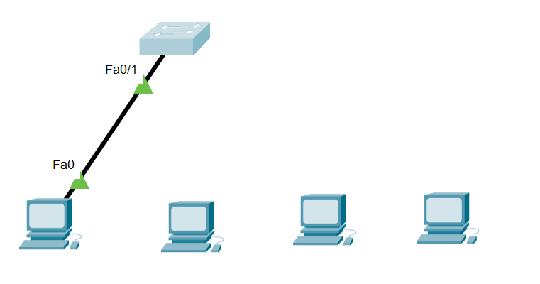
interface fastEthernet 0/2
switchport mode access
switchport port-security
switchport port-security mac-address sticky
switchport port-security maximum 2
exit

Ether channel
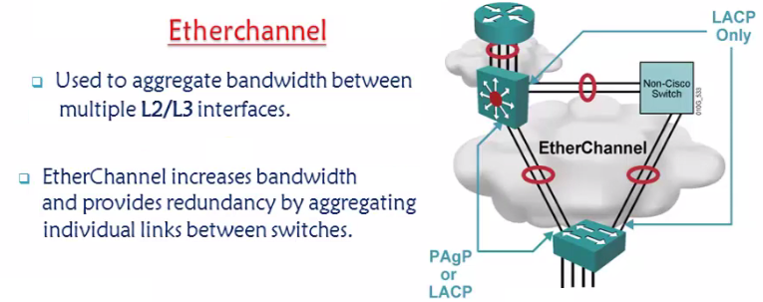
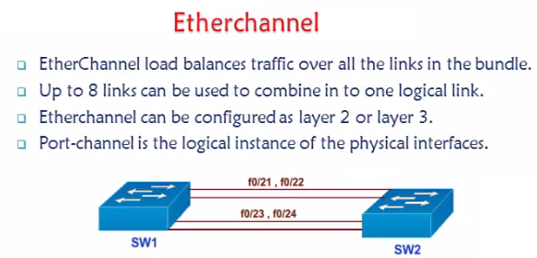
To configure etherchannel -both the switches should have same
Speed,duplex,same Vlan and same set of configurations.
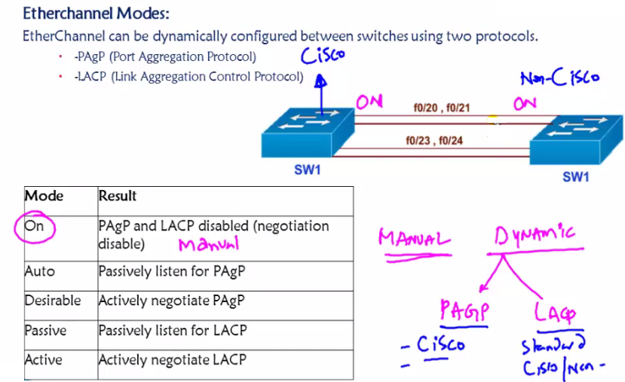

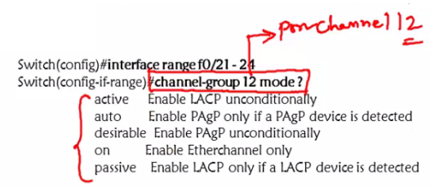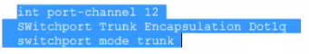
Whatever changes that we do on logical interface – same changes will happen to the physical interfaces.
Verification commands – Show ether channel summary , show ip int br ,
Any implementation on port channel will impact the indivisual switch

Switchport trunk encapsulation dot1q / ISL
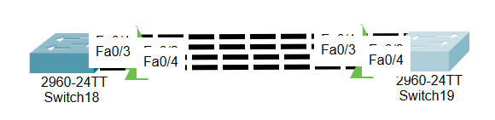
SW1
SW1(config)#
interface range fastEthernet 0/1 - 4
channel-group 2 mode desirable
exit
interface port-channel 2
switchport mode trunk
exit

SW2
SW1(config)#
interface range fastEthernet 0/1 - 4
channel-group 2 mode desirable
exit
interface port-channel 2
switchport mode trunk
exit

FRAME RELAY WITH SUB INTERFACES.

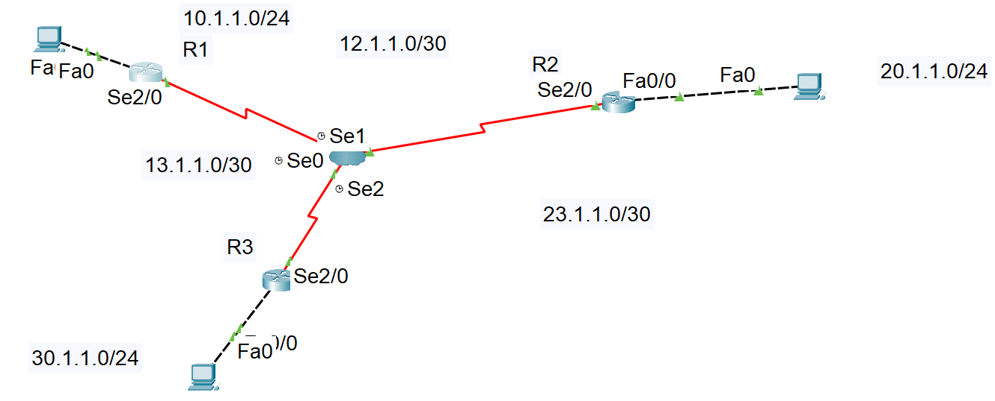
R1
interface fastEthernet 0/0
ip address 10.1.1.10 255.255.255.0
no shutdown
exi
hostname R1

R2
interface fastEthernet 0/0
ip address 20.1.1.10 255.255.255.0
no sh
exit
hostname R2
R3
interface fastEthernet 0/0
no shutdown
ip address 30.1.1.10 255.255.255.0
no shutdown
exit
hostname R3

R1
router eigrp 100
network 23.0.0.0
network 12.0.0.0
network 10.0.0.0
no auto-summary
exit
R2
router eigrp 100
network 12.0.0.0
network 20.0.0.0
no auto-summary
network 23.0.0.0
exit
R3
router eigrp 100
no auto-summary
network 23.0.0.0
network 13.0.0.0
network 30.0.0.0

exit

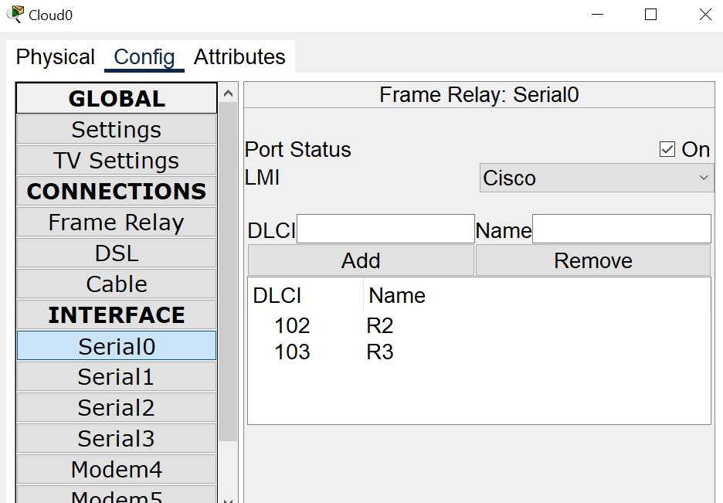
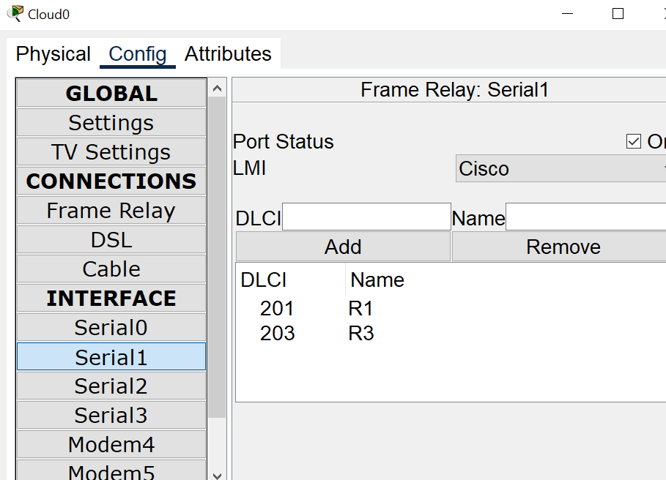
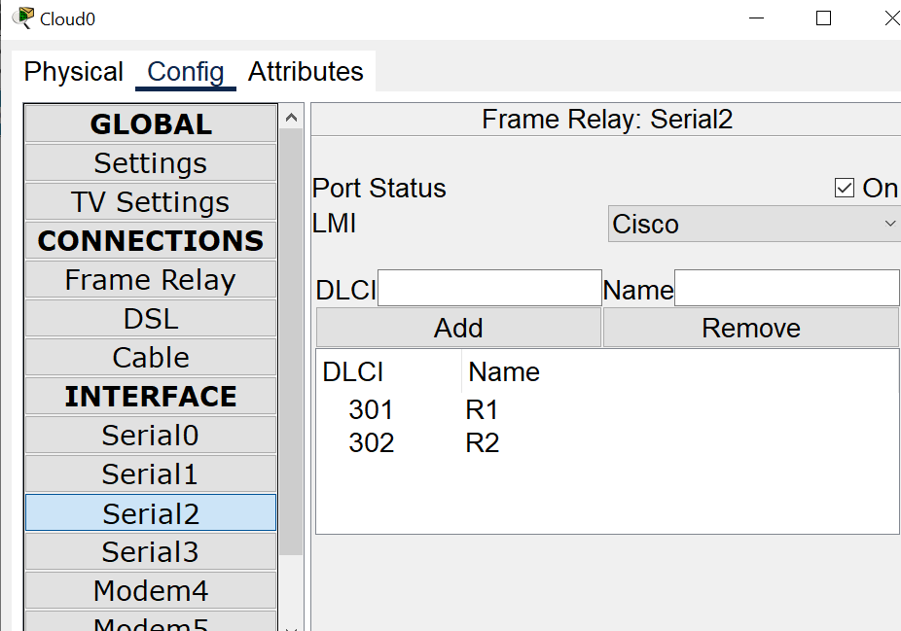

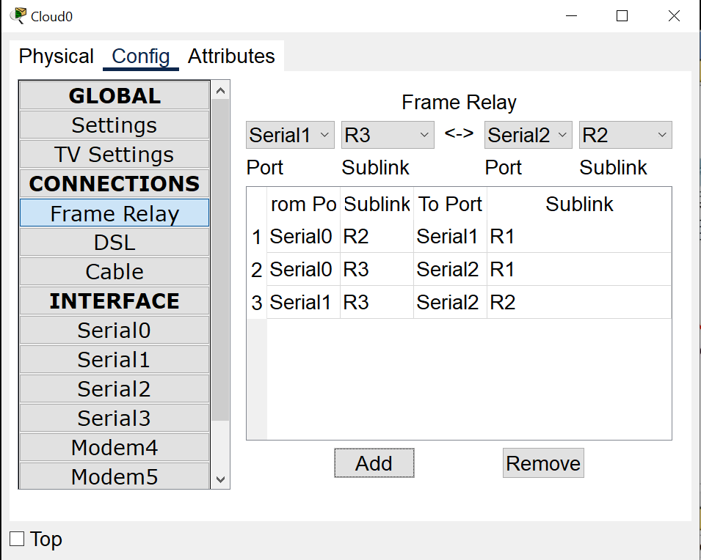

R1
interface serial 2/0
no ip address
no encapsulation frame-relay
exit
R2
interface serial 2/0
no ip address
no encapsulation frame-relay
exit
R3
interface serial 2/0
no ip address
no encapsulation frame-relay
exit
R3
interface serial 2/0
no shutdown
encapsulation frame-relay
exit

interface serial 2/0.301 point-to-point
ip address 13.1.1.2 255.255.255.252
bandwidth 64
frame-relay interface-dlci 301
exit
interface serial 2/0.302 point-to-point
ip address 23.1.1.1 255.255.255.252
bandwidth 64
frame-relay interface-dlci 302
exit
R2
interface serial 2/0
no shutdown
encapsulation frame-relay
exit

interface serial 2/0.201 point-to-point
ip address 12.1.1.2 255.255.255.252
bandwidth 64
frame-relay interface-dlci 201
exit
interface serial 2/0.203 point-to-point
ip address 23.1.1.2 255.255.255.252
bandwidth 64
frame-relay interface-dlci 203
exit

R1
interface serial 2/0
no shutdown
encapsulation frame-relay
exit

interface serial 2/0.102 point-to-point
ip address 12.1.1.1 255.255.255.252
bandwidth 64
frame-relay interface-dlci 102
exit
interface serial 2/0.103 point-to-point
ip address 13.1.1.1 255.255.255.252
bandwidth 64
frame-relay interface-dlci 103
exit

